# CS 255 System Design Document Template

This template lays out all the different sections that you need to complete for Project Two. Each section has guidance to prompt your thinking. You will need to continually reference the interview transcript as you work to make sure that you are addressing your client’s needs. There is no required length for the final document. Instead the goal is to complete each section based on what your client’s needs are. Remove this note when you are finished, and replace all bracketed text with the relevant information.

## UML Diagrams

### UML Use Case Diagram

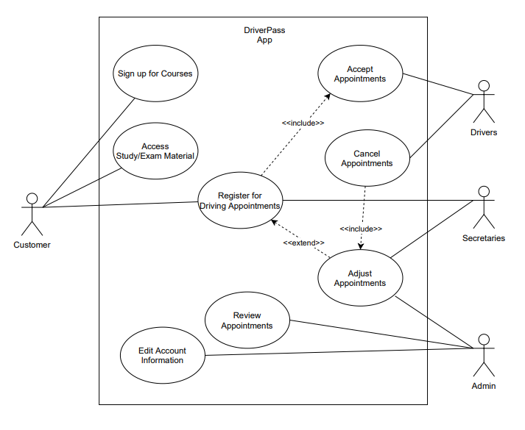

### UML Activity Diagrams

### UML Sequence Diagram

### UML Class Diagram

**Note**: Our ‘Admin’ class inherits every other class because the ‘Admin’ role can perform any action within the application.

## Technical Requirements

As per the meeting with the DriverPass owners. Our system will need to possess decent storage capabilities that can be accessed offline. Meaning, we will have a cloud based storage system. This will allow those with the ‘Admin’ role to download relevant information for use on home computers when not online. The cloud storage will need to be offset to a third party company so that maintenance can be handled outside of the main workflow for the business (as requested by the owners). Furthermore, we’ll need to be able to provide working software for each mainstream OS. This includes Windows, Mac, and Mobile platforms and will allow for customers to access the application from various hardware/software setups. Finally, we’ll need to link into the DMV database for real time updates on any information and legal changes that will affect the courses offered by DriverPass.